# MODULE-II – “Teacher Verification and Sign Up Page”

## **2.1 DESCRIPTION OF THE MODULE:**

This module is responsible for the Verification page and its following Sign-Up page as well as the Personal Details page that is needed for signing up a new teacher. This module also includes the home page for the Teacher’s side that opens up when starting the application.

This module consists of the following classes:

***Class (“Step1”):*** This is the home page of the teacher-side classes, where the admin-side and the teacher-side classes are differentiated using color. Red is for the Teacher side classes, and blue is for the Admin Side classes. This is just a home page displaying a quote and an image.

***Class (“Step2”):*** This is the sign-up, page or to be more precise Verification page, where a user can come to this page, and get verified. The name, college ID, and password will be provided by the admin. Else; they cannot enter after this page. Only when the user enters the proper college ID and others. The user will be redirected to a sign-up page.

***Class (“Step3”):*** This class is where the user comes, if and only if he/she passes the “Step2” class. Once the user comes to this class, they have to enter their email, and password. These credentials will be stored, and further, when they sign in.

***Class (“Step4”):*** This is the final page in the flow or the process of signing up a new teacher. The teacher now has to fill in all their personal details on this page. And all this data again is stored, and all this data of the teacher is visible to the admin. And once the staff fill’s the page, he/she will be a teacher in this respective college. With this, the process of signing up a new user is finished.

After this, the user can now log/sign in and access and utilize this application for timetable updation.

## **2.2 MOTIVATION OF THE MODULE:**

The motivation behind developing this module is to provide a secure and user-friendly Sign-up and verification system and a home page for the application. The home page is essential for any application we make and is the first page that comes up when we start the program. Login, timetable updation, getting the teacher information, and other options provided by the other modules of this project can only be accessed once the teacher signs up.

## **2.3 RELEVANCE OF THE MODULE IN THE SYSTEM:**

The user must be first recruited by the admin on the admin side of the application, and using the information entered, the newly added teacher should verify with their name, college ID, and password provided by the admin.

For verification, the teacher has to enter the name, college ID, and password given by the admin. If these are correct then it verifies it and goes on to get the teacher’s sign up where the user can give their email ID and password followed by a personal information page.

Only once these details are filled in, can a teacher update their timetable and do use the other facilities given by this program.

1. ***User Verification:*** The program then checks if the data entered and the basic teacher information on the admin side are the same and verifies it.
2. ***New teacher sign-up:*** This module on the sign-up page enables teachers to register themselves as users of the application. It involves the inputting of the email ID and password of the user.
3. ***User Management:*** This module also allows the application to maintain a database of registered teachers, and store their credentials such as name, email id, address, educational qualifications, department, etc securely.

## **2.4 UML OF THE MODULE:**

## **2.4.1 UML for Step1 class:**

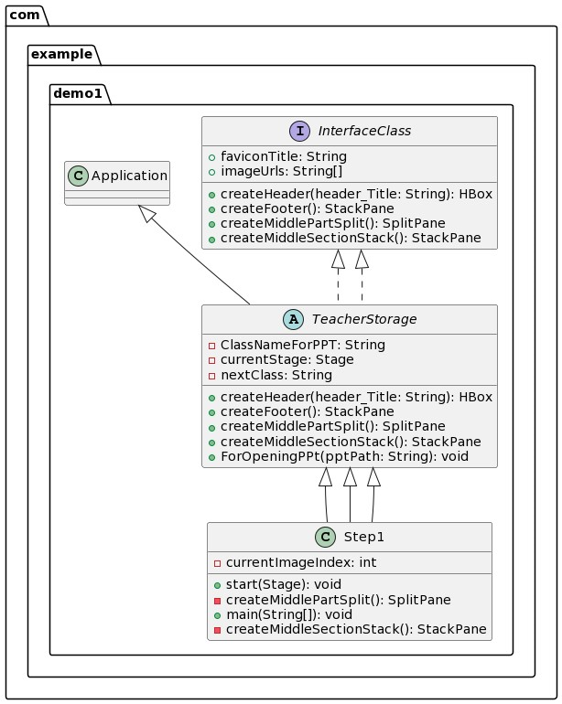

**Figure 1** UML for step1 class

## **2.4.2 UML for Step2 class:**

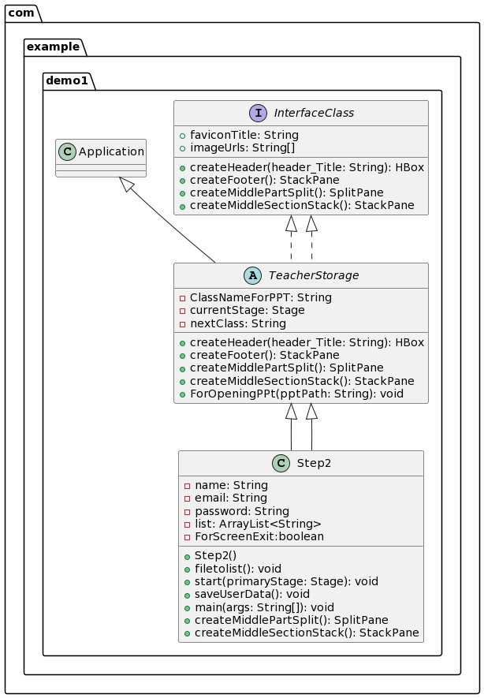

**Figure 2** UML for step2 class

## **2.4.3 UML for Step3 class:**

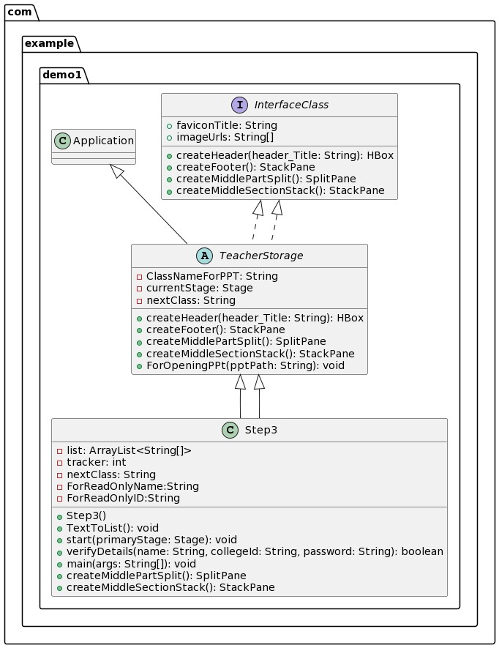

**Figure 3** UML for step3 class

## **2.4.4 UML for Step4 class:**

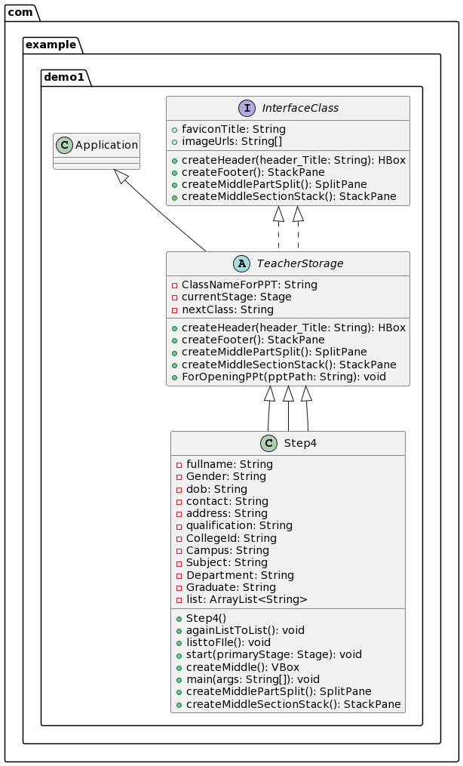

**Figure 4** UML for step4 class

## **2.5 OUTPUT OF THE MODULE:**

## **2.5.1 Output for Step1 class:**

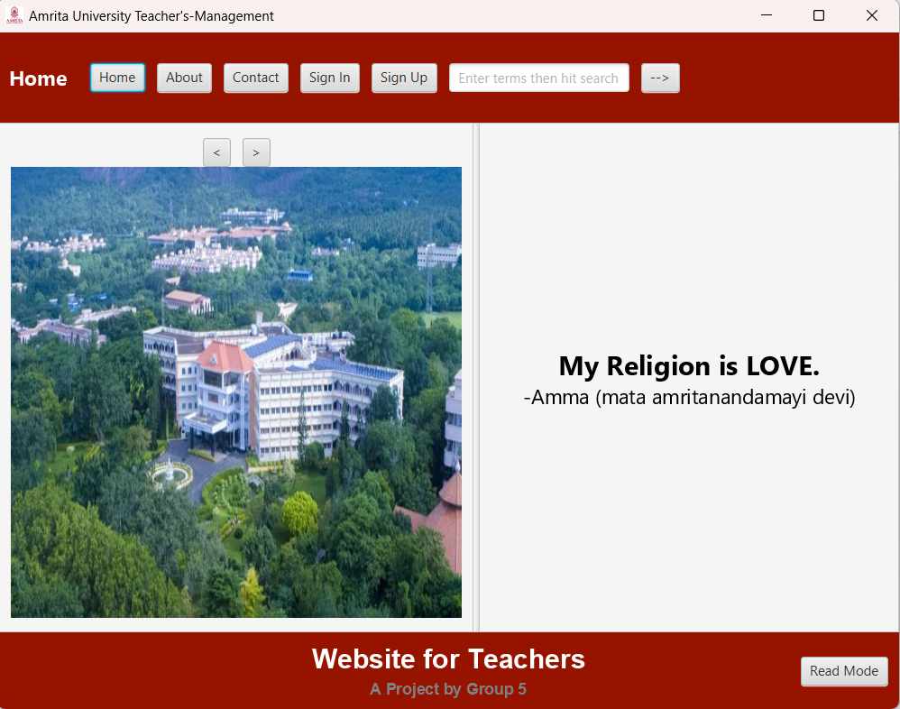

**Figure 5** Home page for teacher's side

## **2.5.2 Output for Step2 class:**

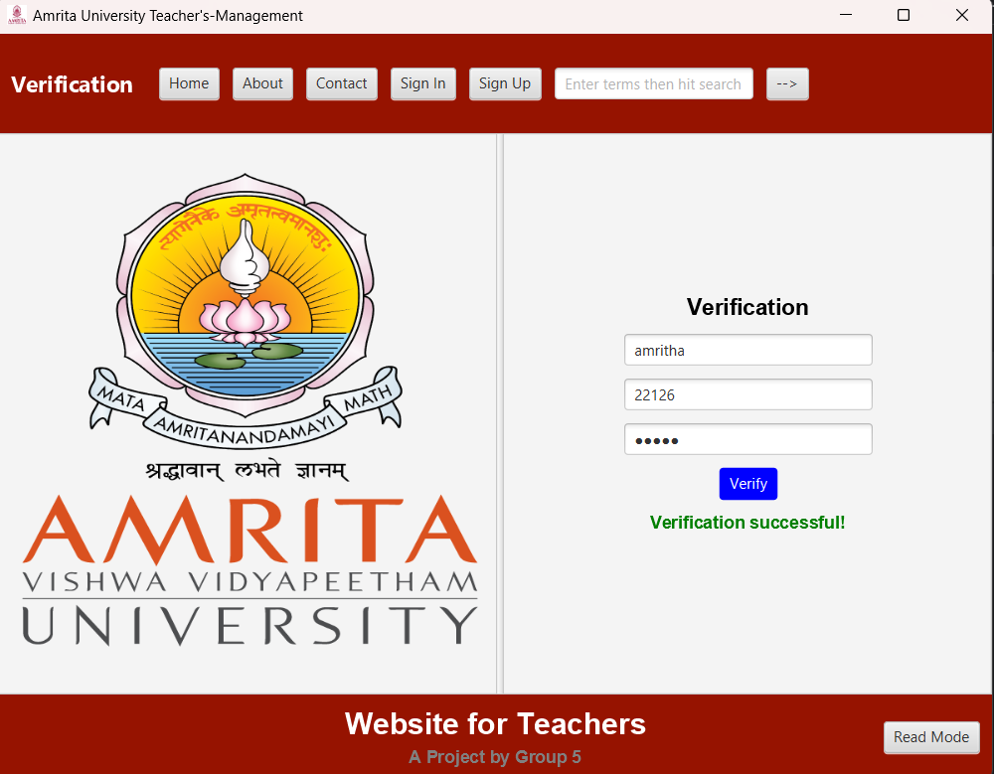

**Figure 6** Verification page

## **2.5.3 Output for Step3 class:**

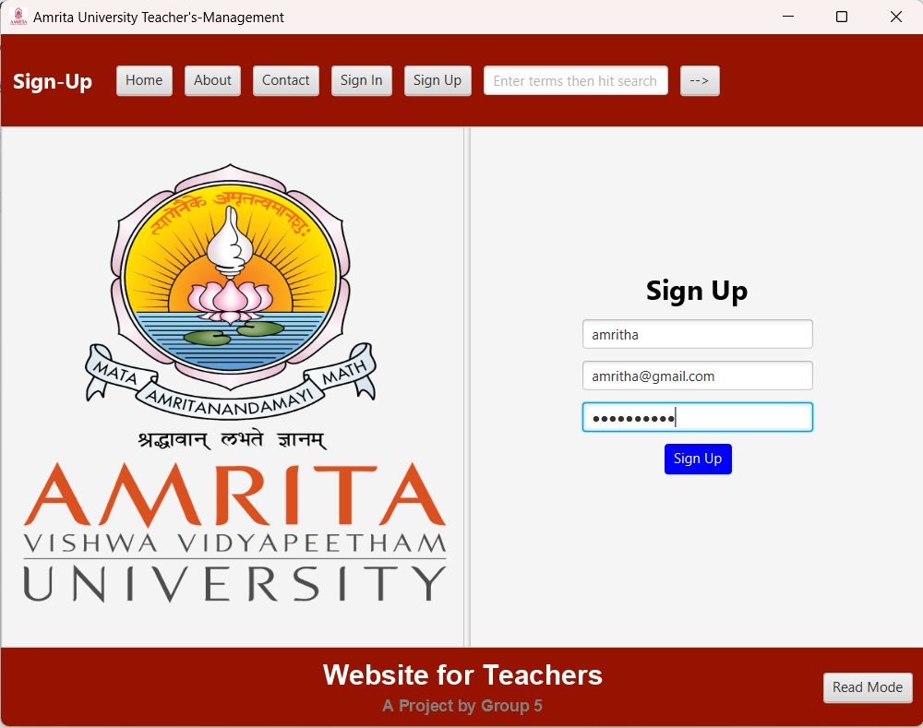

**Figure 7** Sign Up page

## **2.5.4 Output for Step4 class:**

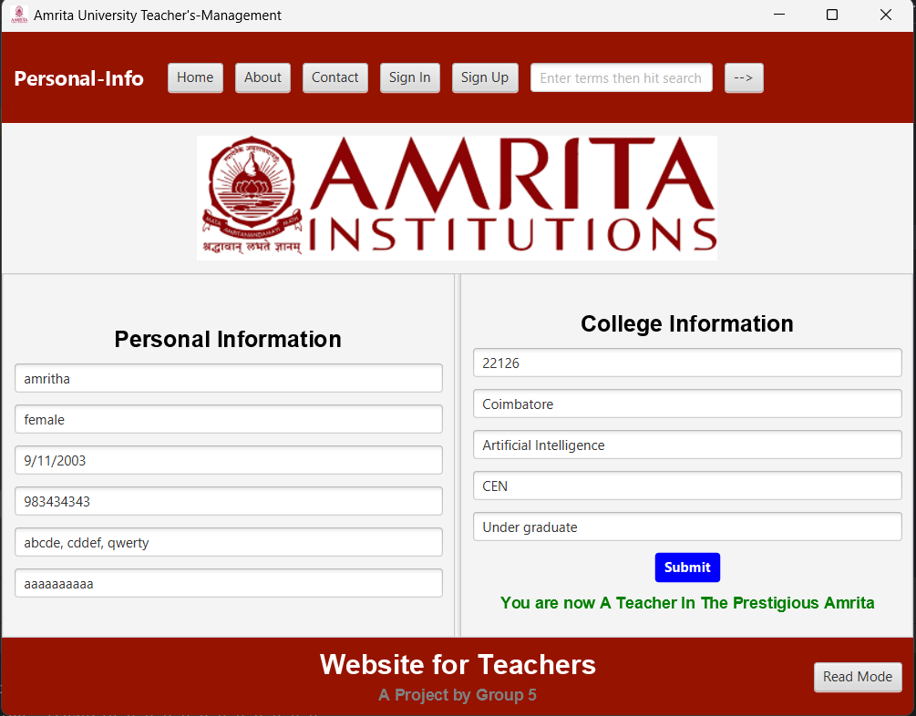

**Figure 8** Personal information page